Lab 10

Isaiah Hoffer

LAB Q 1:

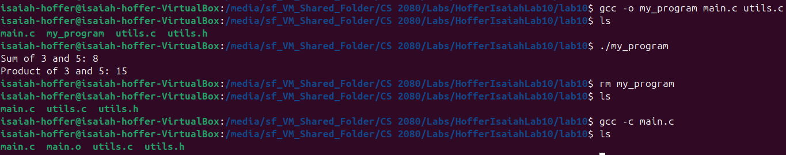

LAB Q 2:

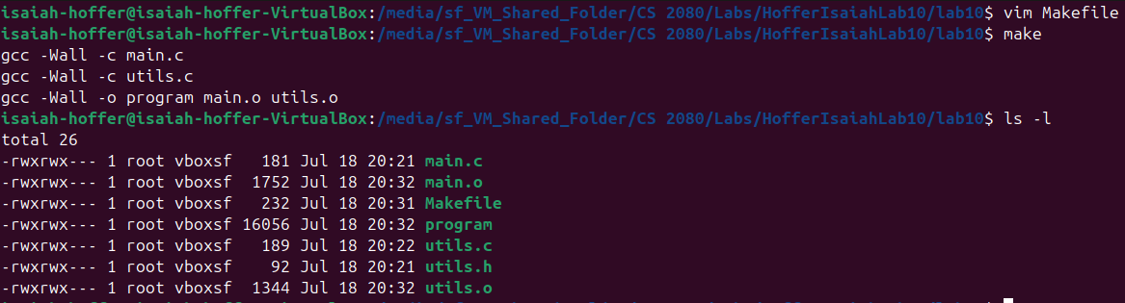

LAB Q 3:

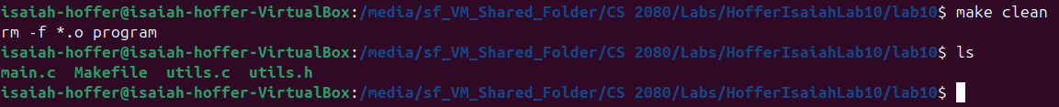

LAB Q 4:

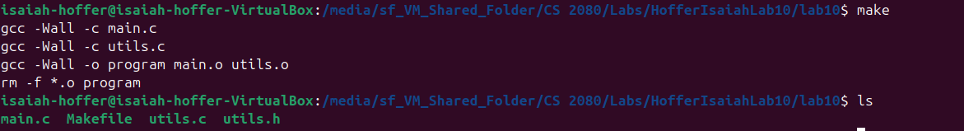

LAB Q 5:

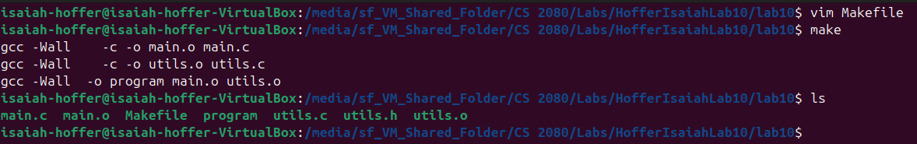

LAB Q 6:

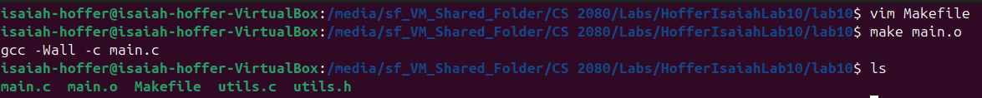

LAB Q 7:

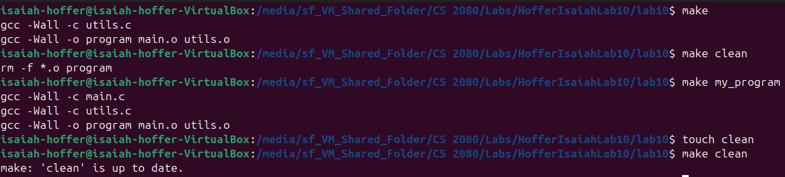

LAB Q 8:

